Rolleston on Dove Neighbourhood Plan

Draft
January 2013

Contents

1 introduction 1
Objectives of the Neighbourhood Plan 2
Statement of Community Involvement 3
2 local context 5
Introduction 5
History of Rolleston on Dove 5
Growth of the village 7
Socio-economic profile 8
3 challenges and opportunities facing rolleston on Dove 9
Challenges 9
Vision and principles 9
Objectives 9
4 housing 10
Housing Requirement 10
Type of housing 14
Affordable housing priority 17
Affordable housing provision 18
Housing allocations 20
5 design 24
Green spaces within new residential development 24
Residential storey heights 25
Energy efficiency of new developments 26
Parking standards 27
Materials and household waste facilities 28
6 open space 30
Development outside the settlement boundary 30
Protection of open spaces of community value 31
Protection of views of local importance 41
7 infrastructure 44
Community facilities 44
Sports/leisure facilities 45
Transport facilities 46

List of policies

Policy H1: Housing requirement
Policy H2: Housing types
Policy H3: Affordable housing priority
Policy H4: Affordable housing provision
Policy H5: Housing allocations and phasing

Policy D1: Green spaces within new residential development
Policy D2: Residential storey heights
Policy D3: Energy efficiency of new developments
Policy D4: Parking standards for new residential development
Policy D5: Materials and refuse bin storage for residential development

Policy OS1: Development outside the settlement boundary
Policy OS2: Protection of open spaces of community value
Policy OS3: Protection of views of local importance

Policy IN1: Provision of a community centre
Policy IN2: Provision of sports/leisure facilities
Policy IN3: Provision of transport infrastructure

introduction
- This document is the Neighbourhood Development Plan for Rolleston on Dove. It covers the area corresponding exactly to that within Parish Council electoral boundary as shown in Figure 1.1.

Figure 1.1: Area covered by Rolleston on Dove Neighbourhood Plan
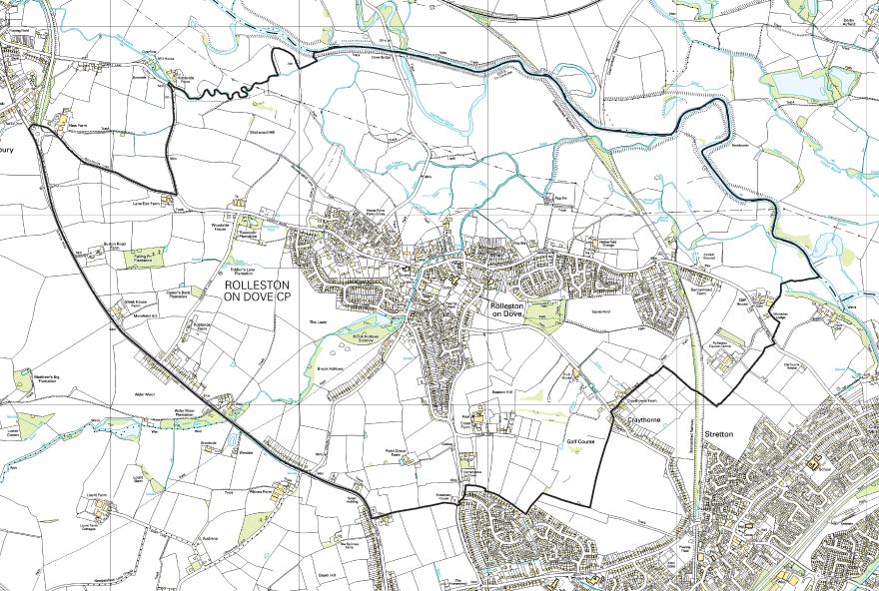
Source: East Staffordshire Borough Council

- The Neighbourhood Plan covers the time period 2012 to 2031 so as to correspond with the Borough Council’s Core Strategy.
- Through substantial consultation of residents and landowners it sets out a view on the amount of development within the village over the time period of the Plan and identifies development sites which are acceptable to the majority of consultees.
- A Neighbourhood Planning Steering Group made up of volunteers working with Rolleston on Dove Parish Council has prepared this Neighbourhood Plan. The Neighbourhood Plan process commenced in October 2011. Complete details of the type of consultation and the people consulted are given in a separate Statement of Community Involvement which is summarised below. A great amount of interest was generated by public meetings and regular newsletters. The return rate for the public questionnaire was considered to be an extremely high figure for this type of exercise.
- This Neighbourhood Plan will be used as a planning document for Rolleston on Dove’s future. It is envisaged that this Neighbourhood Plan will support Rolleston on Dove’s development and support future planning decisions for the village for the next 19 years.

Objectives of the Neighbourhood Plan
- The Neighbourhood Plan has five core objectives. They are:
- Objective 1: The community accepts some new homes are necessary but these should be built in the most sustainable and least impacting areas of the village, preserving the village atmosphere for future generations.
- Objective 2: The preservation of the village of Rolleston on Dove from merging into the suburbs of Burton, Stretton and Tutbury, thereby losing its important identity.
- Objective 3: The protection of green open space used for sport and recreation.
- Objective 4: For the scale of development to be in keeping with the village. In particular, large housing developments are not acceptable within the village.
- Objective 5: Developments should meet the housing needs of the local community and be designed to be in keeping with the existing properties in the village.

Statement of Community Involvement
- A key part of the Neighbourhood Development Plan process is using a variety of methods of consultation to reach different audiences, especially groups of people who sometimes find it difficult to make their voice heard, or who rarely get involved in Community Projects.
- The Neighbourhood Plan Steering Group felt community engagement was essential for drafting a Neighbourhood Plan that reflected the village’s interests and to shape its future. Community involvement was actively encouraged incorporating the reality that there will be some level of development in the village in the years to come.
- In December 2011 after the formation of the group, the first newsletter was circulated to every home in the village. Copies were also placed on the Village’s website and noticeboards. In January 2012 the Steering group held drop in sessions for villagers over two weekends at prominent locations within the village and also canvassed residents outside of Starbucks Newsagents and the Co-Op over two bitterly cold weekends. Representatives from the group met with the following village groups and organisations during January 2012:
- Rolleston on Dove Women’s Institute
- Rolleston Beaver & Scouts
- Doveside Women’s Institute
- Rolleston Kindergarten
- Rolleston on Dove Allotment Society
- Starbucks (newsagents)
- Rolleston Civic Trust
- Co-op
- Rolleston Cricket Club
- Ian Barker Butchers
- Grass Roots (hairdressers)
- The Florist Gate (florists)
- Rolleston Service Station
- St Mary’s Church
- John of Rolleston Primary School (staff & helpers)
- Craythorne Farm Shop
- Public Houses & Rolleston Club
- The group was also represented with a display at the following events during May and June 2012:
- Queens Diamond Jubilee Weekend
- Rolleston Transport Festival
- John of Rolleston School Community Day
- In February 2012 the group circulated a second newsletter to every home in the village. Once again copies were also placed on the Village’s website and noticeboards. This was followed by a third newsletter in April 2012. The April newsletter was followed by the delivery of the Questionnaire to every home in the village with additional copies located in Starbucks newsagents.
- Questionnaires were delivered to every household in the parish, numbering approximately 1,450. In total, 556 questionnaires were returned, representing a 39% response rate. A full copy of the results can be found in the Appendices.
- In August and September 2012 two further consultation events took place in which villagers were presented with some sites for potential development and asked to identify their preferred sites. Consequently the sites most preferred for development have been included within this plan.
- The steering group was made up of representatives from the Parish Council, Rolleston Civic Trust and village residents. The elected Chairman was a member of the Parish Council and monthly updates were provided to members of the Parish Council. For voting purposes each member of the group was allowed one vote.
- A copy of the timetable that the group worked to can be found in the Appendices.

local context

Introduction
- Rolleston on Dove is an attractive village lying in the Dove valley between the Rivers Dove and Trent. To walk down the Alder Brook from the Brook Hollows Spinney, through the centre of the village past the Almshouses, the Croft and the Spread Eagle Inn, over the old bridge and on down Brookside, is a delight. This area is acknowledged to be one of the jewels of Staffordshire.
- The combination of the attractiveness and the community spirit makes Rolleston a very desirable place to live. This attraction of the village is a double edged sword, and it is to prevent the village being spoiled by large, unwelcome and unplanned development that this Neighbourhood Development Plan was undertaken.
- In addition, the community spirit in the village and the involvement of the villagers is not matched by any other village in the area. This is borne out by the Place Survey undertaken by the Borough Council. This community spirit has not come about by chance and is a result of much hard work by many residents over the years.
- The village has a population of 3,267 with 1,433 residential properties (source: 2011 Census).

History of Rolleston on Dove

The Development of Rolleston and Tutbury
- A comparison of the two neighbouring, similar-sized villages is instructive when looking at the history and development of Rolleston. The communities of Tutbury and Rolleston, lying in the valley of the River Dove, have signs of habitation since the Stone Age. Today, with similar 3,000+ populations they show two very different forms of development.
- After the Norman Conquest and building of Tutbury Castle, “The Honor of Tutbury” became the administrative centre for that village and the surrounding feudal estates, including Rolleston. The foundation of a Benedictine priory followed that of the castle. Tutbury was created a borough with fair and market, it became important for the mining of a very pure alabaster sand. It was also a focal point for the crossing of the Dove. The status of Tutbury fluctuated, declining to that of a village but it revived in the 18th century with the establishment of a school and an influx of professional residents. New industries included a cotton mill and glassmaking. Supported by a railway station later developments included a creamery. Today the principal industry is the Nestle instant coffee factory and Tutbury is mainly residential. The developments of the past, however, have sustained a service and administrative structure for a largely self-supporting community. These developments are detailed in the Victoria County History of Staffordshire which regards them as a process of urbanisation.
- The old ecclesiastical parish of Rolleston included Anslow and parts of Tatenhill with a boundary at the Forest of Needwood. Following the creation of Anslow parish in 1861, the present village is restricted to the northern section of the original area. The modern Rolleston on Dove itself combines two small, older communities, the larger, Rolleston, based around the ancient centre with Church and Hall and a smaller population about one mile to the east, based on a service centre to the Rolleston on Dove railway station which arrived in 1894. The station was called Rolleston on Dove to distinguish it from Rolleston station in Nottinghamshire.
- Rolleston estate was held by the family of that name from the 12th Century until it was sold to Sir Edward Mosley in 1620. The estate continued to be held by the Mosley’s until they left in the early 20th Century. Extensive purchases, especially in the 19th century resulted in an estate described in the Estate sale catalogue of 1919 as a “Manorial, Residential, Agricultural and Sporting Estate extending to nearly 3,825 acres” and “Embracing practically the whole of the parish of Rolleston and considerable portions of the parishes of Anslow and Tutbury”.
- The Mosley’s held the village as a “feudal” agricultural estate with little development of industry apart from traditional crafts such as a smithy, basket making or brick making for estate properties. After the Estate sales, large areas of land to the south of the village were purchased by Staffordshire County Council to create starter farms for soldiers returning from World War One. These retained the primarily agricultural nature of the area.
- The village maintained little more than a butchery, bakery and general store for basic needs. The main purpose of the railway station was for movement of agricultural raw materials and products, supported by limited commuter travel. Greater consumer needs were provided from either Burton or Tutbury.
- With improvements in public and mainly, private transport there have been increasing pressures on Rolleston as a residential, commuter base for the surrounding area. In addition to its rural and country estate aspect it has enjoyed a strong reputation for community spirit.
- Figures in the County History give a population of around 850 in the period 1901 – 1931. This grew to 1,330 in 1951, 2,162 in 1961, 3,636 in 1971, 3,574 in 1981, 3,119 in 1991 and 3,134 in 2001. These figures parallel the development of housing estates [see section2.3]. There has been ribbon infilling of the land between the old centre and the former station to the south of the flood plain and movement south and west towards Stretton and Burton. In 1945 there were around 18 farms in the village, 14 of them producing milk. By 2000 this had been reduced to five with two milk producers. Most farmhouses and outbuildings together with land close to the village had been converted to housing.
- At no time has there been supporting infrastructure for this expansion. The provision of a High School (1963-1985) was short-lived and recent attempts to provide a medical centre failed. With past developments the modern village has coalesced into a large housing complex highly reliant on external services and resources for its maintenance.

Growth of the village
Date | Size | Development | Description
ca 1935 | 40 | Knowles Hill | A development of semi-detached council houses (8 now privately owned) plus private housing.
1936 | 29 | Walford Road (bottom) and Fairfield Avenue | Well built, solid walled detached and semi-detached houses of differing designs. Building stopped at the start of the war.
1960 | 224 | The Lawns and Hall Road | A mixed development on the Hall lawns and adjacent land in the centre of the village, next to the Moseley estate fishing lake. Originally included two shops. The whole estate was completed by 1964
1959 | 89 | Walford Road | A mixed development of semis, detached and bungalows.
1954-56 | 125 | Elizabeth Ave/Beacon Drive/Dodslow Ave council estate | A large council estate, many now privately owned; including some sheltered bungalows. Many originally of Airey design/construction. Complex evolution; Cedar houses c1948, Airey Homes c1953
1964 | 25 | Glebe Close/ Marston Lane (part) | A small 60’s development, mainly detached houses
1965 | 41 | Twentylands | A development of detached houses. The name Twentylands refers to the field called 20 lants (its size in old strips)
c1969 | 15 | Croft Close | A central cul-de-sac of bungalows
 | 18 | Hawksley Drive | A quiet cul-de-sac of bungalows and houses.
c1967 | 44 | Alderbrook Close/ Station Rd | A quiet cul-de-sac of typical 60’s houses.
c1980 | 92 | Meadow View | An spacious development with relatively large, open, front gardens
2000 | 41 | Shotwood Close | An attractive mixed development including some starter homes.
2002 | 91 | Forest School site | A mixed development on the site of the Forest of Needwood school.
2007 | 11 | Alders Reach | A small development in the grounds of the Dower House
Notes:
Date refers to when the development was started. Some dates are only approximate.
Size (except for Elizabeth Ave/Beacon Drive/Dodslow Ave council estate) refers to the number of houses in the original development. This is now difficult to determine in many cases and is approximate.
Areas which were developed piecemeal (such as South Hill) and other small developments (less than 10 houses) are not included in the table.

Socio-economic profile
- A full socio-economic profile can be found on the Borough Council’s web site. All information in this section is taken from that source.

Population
- The 2011 Census gives a population for Rolleston of 3,267 of which 34.9% were aged 60 or over. Rolleston has a large and rising population aged 60 and over as the same proportion in 2011 was only 20%.

Housing
- The 2011 Census identified 1,433 households in Rolleston. This an increase of 7.1% on the 2001 Census figure.

Economic activity
- The aging population of the village is borne out by the fact that 66.0% of the population of Rolleston are economically active compared to 70.5% of the population of East Staffordshire as a whole. Of those residents who are economically active, 46.6% are classed as Managers, Professional or Technical. This figure is significantly higher than that for East Staffordshire and for England and Wales. This is again borne out by the fact that more than 35.7% of people in Rolleston are qualified to degree level or higher.
- In 2008 the average household income across Rolleston was £44,800 which is significantly more than the average across East Staffordshire of £36,800.

Travel to work
- Because of the nature of employment of most of the workers, very few of them work in Rolleston or from home. The vast majority (almost 80%) travel to work by private motor vehicle.

Health
- The residents of Rolleston tend to live a healthier lifestyle than the average in East Staffordshire and England. The life expectancy of residents is almost three years more than the average for East Staffordshire as a whole. This is in spite of the anecdotal evidence from local doctors that the Dove Valley is unhealthy due to the damp environment. This increased life expectancy can only add to the problems of an increasing aging population in the village.

challenges and opportunities facing rolleston on Dove

Challenges
- The biggest challenge facing the future of Rolleston on Dove is to protect the charm of the village, whilst allowing it to continue to evolve in a sensitive manner.
- Another challenge for the future is that the village does not have the infrastructure to support the needs of aging residents. There needs to be a balance in supporting those who have been a part of the community for a long time, whilst ensuring that future generation’s interests are also catered for. This will then enable Rolleston on Dove to be a flourishing village for decades and centuries to come.

Vision and principles
- The vision of Rolleston in the future is a vibrant community, physically separate from Burton on Trent. It will continue to be an attractive village with its heart based around Burnside. The vision is of a distinct, vibrant community and not a mere dormitory settlement for surrounding towns and cities.
- It is accepted that Rolleston will see some development over the next 19 years. Any development should not be visually intrusive. The Lawns is a good example of this, walking past the bottom of the Lawns (a large estate) one just sees a few houses facing Brook Hollows – the rest is hidden.
- A strong principle is that individual developments should be of a scale appropriate to the village. Large housing estates tacked onto the edge of Rolleston are not considered appropriate.
- To help make sure that Rolleston retains its community spirit, the village needs a meeting room in the centre of the village where the different organisations can meet to shape the future.

Objectives
- Throughout the numerous consultation exercises undertaken to inform the Neighbourhood Plan, the community of Rolleston on Dove has provided very important views on its aspirations for the village over the coming years. This plan sets out important objectives to meet many of these. They are:
- Objective 1: The community accepts some new homes are necessary but these should be built in the most sustainable and least impacting areas of the village, preserving the village atmosphere for future generations.
- Objective 2: The prevention of the village of Rolleston on Dove merging into the suburbs of Burton, Stretton and Tutbury, thereby losing its important identity.
- Objective 3: The protection of green open space used for sport and recreation.
- Objective 4: The scale of development to be in keeping with the village. In particular, large housing developments are not acceptable within the village.
- Objective 5: Developments should meet the housing needs of the local community and be designed to be in keeping with the existing properties in the village.

housing
- This section of the Neighbourhood Plan considers the amount, location, type and phasing of housing development over the plan period.

Approach
- East Staffordshire Borough Council (ESBC) is required to establish its housing requirements by using the Office for National Statistics’ (ONS) 2010-based population projections and the Department for Community and Local Government’s (DCLG) 2008-based household projections. This is then coupled with an assessment of sites for development and infrastructure requirements to derive the Local Plan strategy. The vast majority of growth is focused in the two main centres of Burton-on-Trent and Uttoxeter.
- Applying such analysis at the Strategic Village level is not ideal. Using district-wide projections to underpin housing requirements at the parish level fails to take into account the location of the parish in relation to the main centres as well as the particular issues affecting such a parish, for example the age of the population. This is a reflection largely of the fact that villages have a relatively low stock of properties when compared to the main urban centres.
- The approach that the Neighbourhood Plan has taken is to use this data where appropriate and to combine it with consideration of the capacity of the key infrastructure which serves the village – in this case the primary school and the GP health services. This is then set alongside an assessment of the sites which have potential to deliver development and which the community considers to be appropriate for development.
- It is a fundamental principle of the Localism Act and the National Planning Policy Framework that neighbourhood plans are permissive planning tools that must plan positively for growth. The policies in the Rolleston on Dove Neighbourhood Plan seek to achieve this. The policies reflect a process which the community has engaged with, fully understanding of the particular need to plan for future growth over a plan period to 2031.

Housing Requirement
- Rolleston on Dove is considered by ESBC to be a ‘Strategic Village’. Strategic Villages are those that, “meet rural needs by providing a good range of facilities and services to their own populations and a wider rural catchment area”. The Local Plan Preferred Option states that development in the Strategic Villages “…would have to be sympathetic and appropriate to their needs”.
- The Local Plan Preferred Option states that the four Strategic Villages of Rolleston on Dove, Tutbury, Barton-under-Needwood and Rocester should accommodate 615 additional dwellings over the plan period to 2031. It then provides housing requirements for each village, coupled with a list of strategic sites and the number of dwellings expected to be delivered on those sites.
- However, Rolleston on Dove Parish Council and the Neighbourhood Plan Steering Group is of the opinion that the scale and location of growth in Rolleston on Dove is a local matter and therefore is best dealt with through the Neighbourhood Plan.
- It is proposed that the Rolleston on Dove Neighbourhood Plan area accommodates 85 dwellings over the plan period from 2012 to 2031. The evidence to justify this figure is contained in Appendix 1.
- This housing requirement consists of the following:
- sites under construction as at 1st April 2012;
- sites with a valid (i.e. non-lapsed) planning permission where construction has not yet begun as at 1st April 2012;
- sites granted planning permission since 1st April 2012;
- site allocations;
- a small allowance for windfall development, which includes sites where a planning application is awaiting determination.
- Table 4.1 shows how this requirement is made up:

Table 4.1: Composition of housing requirement for Rolleston on Dove parish, 2012-2031 (as at 1st January 2013)
Sites |  | No. of  dwellings
Sites under construction or with planning permission as at 1st April 2012 |  | 15
Highfield Garage | 6 dwgs
Adjacent to 4 Marston Lane | 1 dwg
Orchard Barn | 1 dwg
186 Station Road | 1 dwg
Kelvingrove, South Hill | 1 dwg
Rear of Rolleston Club | 3 dwg
29 Beacon Drive | 1 dwg
59 Beacon Road | 1 dwg
Sites granted planning permission  since 1st April 2012 |  | 21
Meadow View | 21 dwgs
Site allocations |  | 24
Land at Shotwood Close | 12 dwgs
Land off Knowles Hill | 12 dwgs
Windfall allowance |  | 25
TOTAL |  | 85

- The plan therefore proposes to deliver an additional 49 dwellings through allocations and a windfall allowance.

Justification
- The Neighbourhood Plan process has not identified an overwhelming urge to only accommodate the needs of local people or those with a local connection. Equally however, it has been strongly felt by the community that Rolleston on Dove is not an appropriate location for significant growth in housing that will make a major contribution to accommodating the wider housing needs of East Staffordshire borough. Rolleston on Dove is a village and lacks the services to support such growth.
- Whilst categorised as a Strategic Village, it is not considered by the Parish Council or the Neighbourhood Plan Steering Group that Rolleston on Dove performs this function in the way that the Strategic Villages should do, as envisaged by the Local Plan Preferred Option. The principal reason for this is that the village lacks the full range of services which are required to serve a wider rural catchment area. Also, some of the key services it does have are at capacity and are therefore unable to serve significant further growth.
- Indeed, Rolleston on Dove’s proximity to Burton on Trent has inevitably had the effect of restricting its growth and the growth of services in the village. People from the wider catchment look to Burton on Trent for many of their basic services, not to Rolleston on Dove. This is shown by the map in Figure 4.1.

Figure 4.1: Map of Rolleston showing physical separation from Burton m Trent
Source: East Staffordshire Borough Council

- It is therefore important that the housing growth proposed for Rolleston on Dove over the plan period is appropriate in scale. The capacity of key services to absorb further growth is paramount. The levels of development being considered have no viable prospect of providing for expansion in the capacity of these services, so Rolleston on Dove’s changing population must be supported by the services as they are currently provided.
- The principal services that will experience the greatest direct impact as a result of new development are John of Rolleston Primary School and the local GP health services.

Education
- As at November 2012, John of Rolleston Primary School has 26 pupil places available across seven year groups, i.e. an average of nearly 4 places per year group. It is recognised that it is prudent to always retain a small degree of slack in the overall numbers on roll, so available places to accommodate additional pupil numbers from planned growth will be lower than this.
- The number of pupils generated by 85 new dwellings is derived from Staffordshire County Council's 'Education Planning Obligations Policy' which was most recently updated in 2008/09. For primary schools, 21 pupils are generated for every 100 houses. Therefore, 85 dwellings would create an additional 18 pupils (an average of 2.6 pupils per year group) who would theoretically be schooled at John of Rolleston Primary School.
- This suggests that there is sufficient capacity to accommodate these additional pupil numbers. Moreover, this leaves an acceptable level of slack at the school as is generally preferred, in order to reflect differences in individual year group sizes. Given that there is no potential for the school to expand and that the next nearest primary school would be too far away to walk or cycle to, so would create additional unsustainable car movements, this is considered to be the maximum level of additional housing that can be supported.

Health
- There is currently no GP surgery within Rolleston on Dove village. The nearest GP is 1.36 miles away in Stretton, which is outside the maximum acceptable distance (1.24 miles) for accessing services on foot as recommended by the Institute of Highways and Transportation (IHT). In total, there are 5 GP surgeries within a 2-mile radius of Rolleston on Dove. All of these surgeries are currently accepting new patients.
- It is considered that significant new development in excess of that proposed would be unsustainable unless a GP surgery was provided in Rolleston on Dove. The difficulty of travelling to the existing surgeries on foot, coupled with cuts to bus services through Rolleston on Dove, means that accessing health services is difficult for those without access to a car and creates increased car movements for others. However, consultation with the South Staffordshire Primary Care Trust has confirmed that they would have no interest in providing a new GP surgery or a satellite surgery in Rolleston on Dove.

Objectives of the policy
- The policy not only seeks to deliver housing to support Rolleston on Dove’s role as a particular type of Strategic Village, close to Burton-on-Trent. It seeks to ensure that there is sufficient range of housing, in the appropriate locations, to address the needs of the changing population of Rolleston on Dove.

Policy H1: Housing requirement
In the parish of Rolleston on Dove, 85 net additional dwellings will be delivered over the plan period 2012 to 2031. Along with sites already in the planning pipeline, these dwellings will be delivered on the allocated sites identified in Policy H4 and through small-scale development on windfall sites.

Policy H1
Objective 1: The community accepts some new homes are necessary but these should be built in the most sustainable and least impacting areas of the village, preserving the village atmosphere for future generations. | YES
Objective 2: The prevention of the village of Rolleston on Dove merging into the suburbs of Burton, Stretton and Tutbury, thereby losing its important identity. | YES
Objective 3: The protection of green open space used for sport and recreation.
Objective 4: The scale of development to be in keeping with the village. In particular, large housing developments are not acceptable within the village. | YES
Objective 5: Developments should meet the needs of the local community and be designed to be in keeping with the existing properties in the village.

Type of housing
- It is important that Rolleston on Dove’s housing growth is able to sustain the changing population of the parish over the plan period. Housing delivered as part of proposed new development must be of the right type to address the needs of the new population. If the mix of new-build housing stock fails to do this, then it is likely to be filled solely by in-migrants to Rolleston on Dove. New migrants to the village are, in themselves, not seen as a bad thing. They help to maintain the vitality of the village, often bringing in young families who will bring their children up here. However, if this means that local residents who require different accommodation to their current dwelling are unable to access this locally and are forced to move out of Rolleston on Dove, then this is an unacceptable position.

Justification
- The composition of Rolleston on Dove’s population is expected to change over the plan period. The Office for National Statistics’ population projections break down the East Staffordshire borough projections by age group. This shows that the predominant growth in population will be those of retirement age – approximately 61% of the change over the period 2008 to 2033 will be people over 65 (Table 4.2).

Table 4.2: Projected population change by age group in East Staffordshire, 2008-2033
Age | Population
 | 2008 | 2033 | Change,  2008-2033
0-19 | 27,000 | 30,000 | 3,000
20-34 | 18,000 | 21,000 | 3,000
35-64 | 46,000 | 48,000 | 2,000
65+ | 19,000 | 33,000 | 14,000
All ages | 110,000 | 133,000 | 23,000
Source: ONS 2010-based population projections
Figures do not sum due to rounding

- Most commonly, people of retirement age living unassisted in their own homes either live alone or with their spouse, i.e. either one- or two-person households. The 61% of the future population that will be of retirement age, when applied to Rolleston on Dove’s proposed growth, represents 106 additional people. This growth of people, based on the number of properties being planned for, will require 0.49 additional dwellings per head of the population, meaning that 52 net additional properties would be need to accommodate people of retirement age.
- However, in reality, not all of these 52 new properties will be needed. The additional older population may not require new properties for the following reasons:
- They are able to find suitable properties for their needs within the existing stock of properties or are happy to stay in their existing ‘family home’.
- They may choose to move in with relatives in the parish.
- They may choose to move into a communal establishment such as a care home.
- It is not possible to know the proportion that would choose to do this, but we have applied a 15% reduction to the net number of additional properties. This therefore reduces the overall need to 44 properties. The calculation is shown below in Table 4.3.

Table 4.3: Forecast number of retirement properties required in Rolleston on Dove, 2012-2031
Additional dwellings, 2012-2031 (A) | 85
Additional population, 2012-2031 (B) | 173
Additional dwellings per additional head of population (C = A / B) | 0.49
Number of people of retirement age (D = 61% x B) | 106
Number of dwellings required by people of retirement age (E = D x C) | 52
Allowance for those finding suitable properties within existing stock, living with relatives or moving into a communal establishment (F = 15% x D) | 8
Total number of retirement properties required (G = E - F) | 44

- This suggests that approximately 50% of the new dwellings proposed for Rolleston on Dove should be properties appropriate for people of retirement age.

Objectives of the policy
- The intention of this policy is to ensure that the needs of the ageing population currently living in Rolleston on Dove are met. This does not mean that 50% of new-build properties should be reserved exclusively for older people. Rather, a proportion of new dwellings on allocated sites should be of the appropriate size and layout for the needs of older people. This gives a greater prospect that existing older residents of the parish can access housing appropriate to their needs, thereby freeing up larger housing for families.
- Equally, this does not prevent the allocation of one or more housing sites solely for properties appropriate for older living. Either way, a balance in the mix of property types will be achieved through the application of the 50% threshold for dwellings appropriate for older people across the allocated sites in Rolleston on Dove parish.

Policy H2: Housing types
Across the allocated housing sites in Rolleston on Dove, up to 50% of the new dwellings shall be appropriate for occupation by older persons.
Such properties shall fulfil all of the following criteria:
- Achieve Lifetime Homes standards, particularly in respect of wheelchair access.
- Be either 1- or 2-bed properties.
This overall requirement can be delivered either across all allocated housing sites or predominantly on a single allocated housing site, with lower levels of such housing provided on the remaining allocated housing sites. Any planning application coming forward proposing housing on one of the allocated sites will be assessed against the outstanding ‘balance’ of housing appropriate for older persons which is still required to be delivered during the plan period in the parish.

Policy H2
Objective 1: The community accepts some new homes are necessary but these should be built in the most sustainable and least impacting areas of the village, preserving the village atmosphere for future generations.
Objective 2: The prevention of the village of Rolleston on Dove merging into the suburbs of Burton, Stretton and Tutbury, thereby losing its important identity.
Objective 3: The protection of green open space used for sport and recreation.
Objective 4: The scale of development to be in keeping with the village. In particular, large housing developments are not acceptable within the village. | YES
Objective 5: Developments should meet the needs of the local community and be designed to be in keeping with the existing properties in the village. | YES

Affordable housing priority
- ESBC provides the borough-wide policy on affordable housing. It is clear from the community consultation that people consider it important that local people with identified social housing needs should be given reasonable opportunity to be housed within the parish.

Justification
- In November and December 2009, Midlands Rural Housing undertook a Housing Needs Survey for Rolleston on Dove. This assessed the need for affordable housing of people with ties to Rolleston on Dove. This might be:
- A person or family currently living in the parish.
- A person or family who has lived in the parish but moved away to find affordable or suitable housing.
- A person or family with work commitments in the parish.
- Retired or disabled persons who have strong local connections.
- The survey identified a need for 9 affordable properties in Rolleston on Dove to serve these needs, none of which have been delivered as at 2012. This position has been endorsed by the current registered provider, Trent and Dove Housing. Clearly there will be additional needs created over the plan period that must also be accommodated.
- Whilst classified as a Strategic Village, Rolleston on Dove is still a village with limited services so is not appropriate as a location to accommodate a significant proportion of the borough’s wider affordable housing needs.
- It is therefore proposed that those with a proven local connection are given first refusal on taking up a new-build affordable property or vacant existing affordable property in Rolleston on Dove parish.

Objectives of the policy
- This policy seeks to ensure that people with a demonstrable local connection to Rolleston on Dove, coupled with some form of proven housing need, are not forced to move away from the village because there are no properties locally that suit their requirements.
- The East Staffordshire Housing Register places applicants in differing bands according to the relative importance of their needs. So those in Band A have a greater priority to be housed in an appropriate dwelling than those in Band B. Only those in Band D are deemed to have little genuine ‘need’ for social housing. The application to go onto the Housing Register also asks whether people have a local connection to an area and whether that area is one in which they would prefer to be housed.
- It is therefore proposed that if a new affordable property is constructed or an existing property becomes vacant in Rolleston on Dove, those with a local connection who are in Bands A to C (i.e. have some form of identified need) are given first refusal on that property. Therefore, someone with a proven local connection in Band C should have priority over an applicant without a local connection in Band A.
- Those in Band D (i.e. no identified need) with a local connection can only be offered a property locally ahead of other applicants without a local connection in Band D.
Policy H3: Affordable housing priority
New-build affordable housing for social rent and existing social housing which is made available to people on the East Staffordshire Housing Register shall be prioritised for people with a proven local connection to Rolleston on Dove, subject to the extent of their needs.
Those with a proven local connection to Rolleston on Dove (as defined on the East Staffordshire Housing Register Application Form) in Bands A to C shall be given priority over other applicants (i.e. those without a proven local connection):
Band D applicants with a local connection shall have absolute priority over other Band D applicants.
A

Policy H3
Objective 1: The community accepts some new homes are necessary but these should be built in the most sustainable and least impacting areas of the village, preserving the village atmosphere for future generations.
Objective 2: The prevention of the village of Rolleston on Dove merging into the suburbs of Burton, Stretton and Tutbury, thereby losing its important identity.
Objective 3: The protection of green open space used for sport and recreation.
Objective 4: The scale of development to be in keeping with the village. In particular, large housing developments are not acceptable within the village.
Objective 5: Developments should meet the needs of the local community and be designed to be in keeping with the existing properties in the village. | YES

Affordable housing provision

Justification
- As stated above, there is a proven need for 9 additional affordable properties at present in Rolleston on Dove. Clearly there will be additional needs arising in the future and equally, existing properties will come forward to address those needs. It is therefore extremely difficult to establish the scale of need for affordable housing over the plan period.
- However, none of the sites allocated for housing in Policy H5 are expected to provide housing in excess of the 25-dwelling minimum threshold for affordable housing required by ESBC. There is therefore a distinct possibility that no new affordable housing could be delivered in the parish over the plan period, despite the proven need. This therefore increases the importance of ensuring that local affordable needs are addressed within the existing stock of social rented properties locally. This is the purpose of Policy H3.
- It will be important for a new housing needs survey to be undertaken at some point during the plan period, with the potential requirement then to review the plan if significant additional local needs are identified.
- Not all properties will be wanted for social rent. Some people on the Housing Register with a local connection do not have needs classified as being significant so the prospect of being housed directly from the Housing Register are slim. For such people who still are unable to buy or rent on the open market, an alternative form of ‘intermediate’ tenure may be the most appropriate. This commonly includes shared ownership properties. It will be important for ESBC and Rolleston on Dove Parish Council to work together to establish an appropriate mix of social rent and intermediate tenures. The Housing Needs Survey recommended that one-third of the 9 properties were for intermediate tenures, so a ratio of 70:30 (social rent to intermediate) is proposed as the wider requirement. This would need to be subject to agreement between ESBC, the Registered Provider, Rolleston on Dove Parish Council and the applicant in each case.

Objectives of the policy
- Affordable housing has been identified as an issue in Rolleston on Dove. Furthermore, a housing needs survey has established that there is a current need locally. Yet the Borough Council policy would mean that no affordable housing would be required to be delivered on any sites in the parish over the plan period. This policy seeks to address the true need for affordable housing.

Policy H4: Affordable housing provision
Since none of the allocated housing sites in Rolleston are large enough to trigger to the ESBC affordable housing threshold of 25 dwellings, all affordable housing is to be provided through the existing housing stock or regeneration of current affordable housing land while being prioritised for people with a local connection (see Policy H3).
The mix of affordable properties that are for social rent or intermediate tenure shall be agreed with East Staffordshire Borough Council, the Registered Provider and Rolleston on Dove Parish Council.

Policy H4
Objective 1: The community accepts some new homes are necessary but these should be built in the most sustainable and least impacting areas of the village, preserving the village atmosphere for future generations.
Objective 2: The prevention of the village of Rolleston on Dove merging into the suburbs of Burton, Stretton and Tutbury, thereby losing its important identity.
Objective 3: The protection of green open space used for sport and recreation.
Objective 4: The scale of development to be in keeping with the village. In particular, large housing developments are not acceptable within the village. | YES
Objective 5: Developments should meet the needs of the local community and be designed to be in keeping with the existing properties in the village. | YES

Housing allocations
- Policy H1 requires that 85 dwellings are delivered in Rolleston on Dove over the plan period 2012 to 2031. It is necessary to allocate sites to deliver the majority of the outstanding balance of this housing requirement. The fundamental criterion for allocation is that these sites must make a significant contribution towards the wider needs of the community as reflected in the other policies in this Neighbourhood Plan. The sites must also be appropriate for housing development in all other respects.

Justification
- As part of the Neighbourhood Plan process, a ‘Call-for-Sites’ exercise was undertaken. This sought to determine if there were any other sites which landowners wished to put forward in addition to those already put forward as part of ESBC’s own Call-for-Sites process. This identified two further sites, both relating to land off Shotwood Close. These sites were then subject to the same assessment as undertaken by ESBC for its strategic housing land availability assessment (SHLAA).
- In total, 17 sites were considered for allocation. Of these sites, 8 were considered to not be suitable for further consideration because they did not fulfil all of the SHLAA criteria. The remaining 9 sites were then subject to public consultation, with the local community giving their views on the merits of each site and its potential to contribute towards the sustainability of Rolleston on Dove and the wider objectives of the Neighbourhood Plan. In addition, the community gave their views on other principles regarding the type of properties considered appropriate for each site.
- The assessment of the sites identified through the Neighbourhood Plan ‘Call-for-Sites’ is shown in Appendix 2. The other sites are included within the ESBC SHLAA which provides the detailed assessment of each.
- In total, four sites were considered suitable for housing development and contributed positively towards the sustainable objectives of the plan. Three of these sites were proposed for allocation but one – the land at Meadow View – has subsequently been granted planning permission for 21 residential units. This has therefore resulted in the allocation of two sites for housing development:

Allocation 1: Land at Knowles Hill
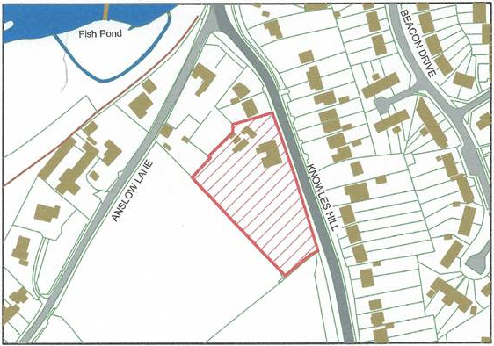
Source: East Staffordshire Borough Council Strategic Housing Land Availability Assessment

- This site totals 0.5 hectares. The site is considered particularly suitable to deliver housing appropriate for older persons, which would need to fulfil the criteria in Policy H2. Therefore the site is considered appropriate for 12 dwellings, all of which should be appropriate for older persons’ accommodation.
- The site could provide a range of dwelling types, provided that they were suitable for occupation by older people. This is therefore likely to be mostly 1- and 2-bed properties. However, depending on the mix, it would need to be ensured that sites coming forward later in the plan period would not have to provide an unacceptably high number of housing units that could address older persons' needs. By ‘unacceptably high’ it is meant that this requirement could compromise the viability of these schemes. This is the reason why the plan seeks all of the dwellings that are delivered on this site to be appropriate for older people.
- Ultimately this will be a judgement for the local planning authority to determine whether the mix of units on any proposed scheme at Knowles Hill would compromise the aim of Policy H2 to ensure that at least 50% of the overall housing requirement is housing appropriate for older persons’ needs.
- In order to phase development appropriately through the plan period, this site should not come forward during the first five years of the plan period. It could only come forward during the first five years if the planning permission granted for residential development at Meadow View was not delivered and the permission expired.

Allocation 2: Land off Shotwood Close
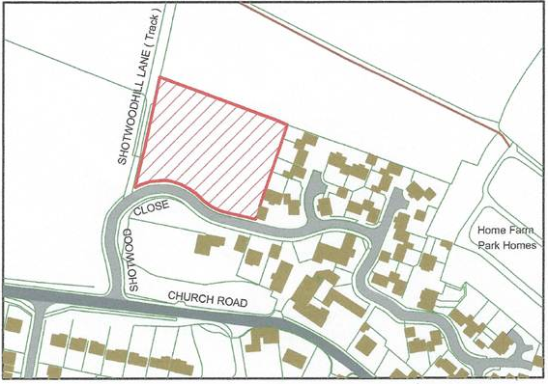
Source: Neighbourhood Plan ‘Call for Sites’ process

- This site was proposed through the Neighbourhood Plan ‘Call for Sites’ exercise and assessed against the SHLAA criteria. It has an area of 0.5 hectares and is ideally suited to form an extension to the existing properties on Shotwood Close. The site is ideally suited to the provision of some 2-bedroom terraced houses, along with some 3- and 4-bedroom detached houses and is capable of accommodating 12 dwellings.
- No property should be higher than two storeys in order to be in keeping with the character of the village's existing properties and to protect views
- In order to phase development appropriately through the plan period, this site should not come forward during the first five years of the plan period.

Windfalls
- The remaining balance of dwellings required to deliver Policy H1 shall be achieved on windfall sites within the village boundary.

Objectives of the policy
- The policy seeks to ensure that a range of appropriate sites come forward to deliver the housing requirements of Rolleston on Dove parish over the lifetime of the plan. These sites are all considered to be sustainable in terms of their proximity to the services in the village. Moreover, they are able to deliver the requirements of Policy H2 and the needs of older people.
- The phasing in the policy seeks to ensure that all the allocated sites do not come forward in the first few years of the plan period, which would potentially subject the key services in Rolleston on Dove to unacceptable levels of strain.

Policy H5: Housing allocations and phasing
The following sites shall be allocated for housing development:
- H5a: Land at Knowles Hill (approximately 12 dwellings providing predominantly 1- and 2-bed properties)
- H5b: Land off Shotwood Close (approximately 12 dwellings with a mix of 2-, 3- and 4-bed properties)

An alternative scheme on the land at Knowles Hill delivering a lower number of units will only be considered acceptable if:
- it does not compromise the potential to deliver the overall housing requirement as identified in Policy H1; and
- sites coming forward later in the plan period would not have to provide an unacceptably high number of housing units addressing older person’s needs, such that this could compromise the viability of the overall scheme.

The sites are to be phased as follows:
- H5a: Land at Knowles Hill – not to come forward in the first 5 years of the plan period unless the permission for residential development at Meadow Hill is not delivered and the permission expires.
- H5b: Land off Shotwood Close – not to come forward in the first 5 years of the plan period.

Policy H5
Objective 1: The community accepts some new homes are necessary but these should be built in the most sustainable and least impacting areas of the village, preserving the village atmosphere for future generations. | YES
Objective 2: The prevention of the village of Rolleston on Dove merging into the suburbs of Burton, Stretton and Tutbury, thereby losing its important identity. | YES
Objective 3: The protection of green open space used for sport and recreation. | YES
Objective 4: The scale of development to be in keeping with the village. In particular, large housing developments are not acceptable within the village. | YES
Objective 5: Developments should meet the needs of the local community and be designed to be in keeping with the existing properties in the village. | YES

design

Green spaces within new residential development
- The biggest challenge facing the future of Rolleston on Dove is to balance the desire to protect the charm of the village with the need for the village to grow and evolve in a sensitive manner. The policies in this section seek to reflect the simple design principles which the community has considered will help to achieve this aim.

Justification
- The parish of Rolleston on Dove’s landscape is dominated by green open spaces and mature trees. It is considered that these principles should be continued with usable green areas of public open space being designed to effectively integrate with the private dwellings on new residential developments. This is only effective on developments of a reasonable scale. It is therefore considered that developments of less than ten dwellings will not have to provide public open space unless there is a lack of public open space within close proximity. However, if such developments do provide public open space when they are not required to, then they should be viewed more favourably.
- Where appropriate in the design of new houses (as distinct from flats), front gardens should be large enough to accommodate the planting of at least one tree per dwelling. This will help to maintain the feel of a village in a rural setting. For flatted development, such a requirement will not be in place. However, such developments should seek to maximise the number of trees that are provided on site. This is particularly the case where any part of the site has public access.
- It is considered that these requirements provide the best prospect of maintaining these principles.

Objectives of the policy
- This policy seeks to ensure that new development is designed to best integrate it into the existing character and pattern of development in Rolleston on Dove and its surrounding area. The sites allocated in Policy H5 have total housing requirements which reflect the need to design appropriate private and public green space into new development.

Policy D1: Green spaces within new residential development
All proposals for new residential development of more than ten dwellings shall provide an appropriate area or areas of public green open space within the development boundary. This space shall be located and designed so that it can practically be used by residents and other members of the public passing through the development.
Sites of less than 10 dwellings shall only provide an appropriate amount of public green open space where there is an existing lack of such space within 400m of the property.
All new houses built (i.e. excluding flatted development) shall include front gardens of sufficient size to plant at least one tree per dwelling.
It will not be considered appropriate to offer an off-site contribution in lieu of on-site provision of green open space and/or trees.

Policy D1
Objective 1: The community accepts some new homes are necessary but these should be built in the most sustainable and least impacting areas of the village, preserving the village atmosphere for future generations.
Objective 2: The prevention of the village of Rolleston on Dove merging into the suburbs of Burton, Stretton and Tutbury, thereby losing its important identity.
Objective 3: The protection of green open space used for sport and recreation. | YES
Objective 4: The scale of development to be in keeping with the village. In particular, large housing developments are not acceptable within the village.
Objective 5: Developments should meet the needs of the local community and be designed to be in keeping with the existing properties in the village. | YES

Residential storey heights

Justification
- It is very strongly felt by the community, local authority and visitors to Rolleston on Dove that some recent developments of more than two storeys are out of character with the rest of the village. Such ‘townhouse’ developments are not considered appropriate for a village setting.
- All new residential development or extensions to existing residential properties shall be restricted to a maximum of two storeys in height. This still permits loft extensions, provided they do not increase the height of the existing property.

Objectives of the policy
- This policy seeks to ensure that new residential development is in keeping with the rest of the village and protects views into and out of the village. A further policy addressing specific views is contained in Policy OS2.

Policy D2: Residential storey heights
All new residential development, or extensions to existing residential properties, should be restricted to a maximum of two storeys in height.
All

Policy D2
Objective 1: The community accepts some new homes are necessary but these should be built in the most sustainable and least impacting areas of the village, preserving the village atmosphere for future generations.
Objective 2: The prevention of the village of Rolleston on Dove merging into the suburbs of Burton, Stretton and Tutbury, thereby losing its important identity.
Objective 3: The protection of green open space used for sport and recreation.
Objective 4: The scale of development to be in keeping with the village. In particular, large housing developments are not acceptable within the village.
Objective 5: Developments should meet the needs of the local community and be designed to be in keeping with the existing properties in the village. | YES

Energy efficiency of new developments
- One issue that is felt by the community of Rolleston on Dove to be important is ensuring that new developments, as far as possible, achieved the highest standards of energy efficiency.

Justification
- Whilst the sustainability of new development is commonly judged in respect of its accessibility by non-car modes, there is always a limit to how sustainable new developments in rural villages can ever be. However, one issue can be addressed in every new development, irrespective of location, is the energy efficiency of the buildings.
- It is recognised that the Code for Sustainable Homes requires particular minimum levels of energy efficiency to be achieved in residential development and these requirements will become increasingly stringent over time. However, this does not stop new development from always seeking to maximise the levels of energy efficiency where possible.
- All new developments should be designed to very high standards of energy efficiency, particularly those within the Conservation Area which commonly require older materials in order to be in keeping with surrounding buildings but which are less energy efficient. New developments should seek where possible to incorporate the use of renewable energy technologies and other low energy techniques, e.g. rainwater harvesting and reed beds.

Objectives of the policy
- This policy seeks to go beyond the minimum standards expected of new residential developments. Rolleston on Dove wants to ensure that new dwellings minimise their energy usage and maximise their self-sufficiency in energy terms.

Policy D3: Energy efficiency of new developments
All new developments should seek, where possible, to be designed to the very highest standards of energy efficiency. New developments should incorporate the use of renewable energy technologies and other low energy systems compatible with the type of development in question.
If it is not possible to incorporate any such technologies or systems into the development because it would make the development unviable, then the applicant must clearly demonstrate that this is the case to the satisfaction of the local planning authority and Rolleston on Dove Parish Council. If needed, an independent expert can be called upon to give an opinion on the viability of the development in light of the information submitted by the applicant. The costs incurred by this expert are to be borne by the applicant.
Any such technologies or systems that are highly visible will be resisted.
Any such technologies or systems which detract from the value of the Conservation Area will be resisted.
All new

Policy D3
Objective 1: The community accepts some new homes are necessary but these should be built in the most sustainable and least impacting areas of the village, preserving the village atmosphere for future generations. | YES
Objective 2: The prevention of the village of Rolleston on Dove merging into the suburbs of Burton, Stretton and Tutbury, thereby losing its important identity.
Objective 3: The protection of green open space used for sport and recreation.
Objective 4: The scale of development to be in keeping with the village. In particular, large housing developments are not acceptable within the village.
Objective 5: Developments should meet the needs of the local community and be designed to be in keeping with the existing properties in the village. | YES

Parking standards
- All new dwellings should have sufficient off-road parking spaces to cater for the residents of that dwelling.

Justification
- Recent developments have provided insufficient off-street parking for the number of cars owned by those occupying the dwellings. As a result, there are high levels of on-street parking which make it difficult for vehicles to pass, particularly emergency vehicles. It also makes it more dangerous for pedestrians who have to cross the road between parked cars.
- It is therefore necessary to impose minimum off-road parking standards for any new development.

Objectives of the policy
- The policy seeks to ensure that developments are designed to include off-road parking. The density of dwelling numbers on the allocated sites in Policy H5 is such that this is considered to be possible with well-designed proposals.

Policy D4: Parking standards for new residential development
For all new residential developments of more than one dwelling, the following minimum standards shall apply for the provision of off-road parking:
- 1-bed house/flat 1 off-road car parking space
- 2-bed house/flat 2 off-road car parking spaces
- 3-bed house/flat 2 off-road car parking spaces
- 4-bed house/flat 3 off-road car parking spaces
- 5+ bed house/flat 4 off-road car parking spaces

Policy D4
Objective 1: The community accepts some new homes are necessary but these should be built in the most sustainable and least impacting areas of the village, preserving the village atmosphere for future generations.
Objective 2: The prevention of the village of Rolleston on Dove merging into the suburbs of Burton, Stretton and Tutbury, thereby losing its important identity.
Objective 3: The protection of green open space used for sport and recreation.
Objective 4: The scale of development to be in keeping with the village. In particular, large housing developments are not acceptable within the village. | YES
Objective 5: Developments should meet the needs of the local community and be designed to be in keeping with the existing properties in the village. | YES

Materials and household waste facilities
- It is considered important by the community in Rolleston on Dove to ensure that the right materials are used to build new developments.

Justification
- In keeping with the other policies in this section, it is important that new residential development is of the highest standards to ensure that it is in keeping with the majority of residential properties in the rest of the village. The intention is not to have a uniform series of properties that all look the same, rather to ensure that new developments respect the features of buildings which make Rolleston on Dove a desirable place to live.
- This policy will simply require new residential developments to have either brick or rendered elevations under tiled roofs.
- In addition, where there is no provision for direct access to the rear of the dwelling other than through the dwelling itself, a suitable store should be incorporated at the front of the dwelling so that wheelie bins for household refuse and recycling can be stored in concealed positions. This ensures that owners of smaller properties are able to store their wheelie bins away from sight at the front of the property where they can easily be accessed for refuse collection.

Objectives of the policy
- This policy seeks to complement the other policies in this section by ensuring that new residential developments maintain the aesthetic quality of properties in the parish.

Policy D5: Materials and refuse bin storage for residential development
All new residential properties will have either brick or rendered elevations and tiled roofs.

Where there is no provision for direct access to the rear of a new dwelling other than through the dwelling itself, a suitable store must be incorporated at the front of the dwelling so that wheelie bins for household refuse and recycling can be stored in a concealed position.

Policy D5
Objective 1: The community accepts some new homes are necessary but these should be built in the most sustainable and least impacting areas of the village, preserving the village atmosphere for future generations.
Objective 2: The prevention of the village of Rolleston on Dove merging into the suburbs of Burton, Stretton and Tutbury, thereby losing its important identity.
Objective 3: The protection of green open space used for sport and recreation.
Objective 4: The scale of development to be in keeping with the village. In particular, large housing developments are not acceptable within the village.
Objective 5: Developments should meet the needs of the local community and be designed to be in keeping with the existing properties in the village. | YES

open space

Development outside the settlement boundary
- The community of Rolleston on Dove has recognised that the neighbourhood plan has to enable a degree of growth. Within the context of Rolleston on Dove being classified as a Strategic Village, the housing policies in this plan demonstrate that the neighbourhood plan is committed to this requirement.
- However, there are also some important principles which must be upheld in order to protect Rolleston on Dove village from unacceptable expansion. In particular, the proximity to the neighbouring settlements of Horninglow and Stretton to the south-east means that further significant development of open fields between these settlements and Rolleston on Dove village will serve to reduce the green gap between them. Given that these settlements are effectively suburbs of Burton on Trent, this would serve to coalesce Rolleston on Dove into the Burton on Trent conurbation, an entirely unacceptable situation.
- The extent of the village settlement boundary is shown in Figure 6.1:

Figure 6.1: Village settlement boundary
Source: East Staffordshire Borough Council

- Therefore, it is proposed that there will be a strong presumption against any development outside the settlement boundary of Rolleston on Dove. This will particularly be the case if development serves to reduce the gap between the village and Horninglow and Stretton.

Justification
- The purpose of the boundary is to define the areas within which certain policies will apply. In particular, it defines those areas within which planning permission will normally be granted for new development, subject to other policies in this Neighbourhood Plan.
- The built-up area boundary also serves to preserve the setting of existing settlement by protecting surrounding countryside from unnecessary development. Without such a policy providing protection to Rolleston on Dove, it is possible that the village could completely change in character, effectively becoming an extension of the built-up area of Burton on Trent. The community has made it clear that one of Rolleston on Dove’s greatest assets is its rural village nature and therefore anything that threatens this should be resisted.

Policy OS1: Development outside the settlement boundary
The boundaries of the built-up area of Rolleston on Dove are defined on the map in Figure 6.1. Development or redevelopment will be permitted within the built-up area boundaries, subject to the other policies in this plan and those of East Staffordshire Borough Council. Outside the built-up area boundaries, development or redevelopment will not be permitted with the exception of sites that have planning permission or are allocated in Policy H5 of this plan. In particular, there is a clear presumption against development which serves to reduce the green gap between Rolleston on Dove village and the settlements of Horninglow and Stretton.

Policy OS1
Objective 1: The community accepts some new homes are necessary but these should be built in the most sustainable and least impacting areas of the village, preserving the village atmosphere for future generations. | YES
Objective 2: The prevention of the village of Rolleston on Dove merging into the suburbs of Burton, Stretton and Tutbury, thereby losing its important identity. | YES
Objective 3: The protection of green open space used for sport and recreation. | YES
Objective 4: The scale of development to be in keeping with the village. In particular, large housing developments are not acceptable within the village.
Objective 5: Developments should meet the needs of the local community and be designed to be in keeping with the existing properties in the village.

Protection of open spaces of community value
- However, the community engagement process has also made clear that the residents of Rolleston on Dove consider the village to have some very valuable green spaces which should be protected from development. This will ensure that an appropriate balance is struck between the growth of the village and its continuing function as a village characterised by the quality of its open spaces.

Justification
- The consultation process has identified a number of different green spaces within the parish which members of the community consider make a positive contribution to life in Rolleston on Dove. These are as follows:

The Croft (Village Green)
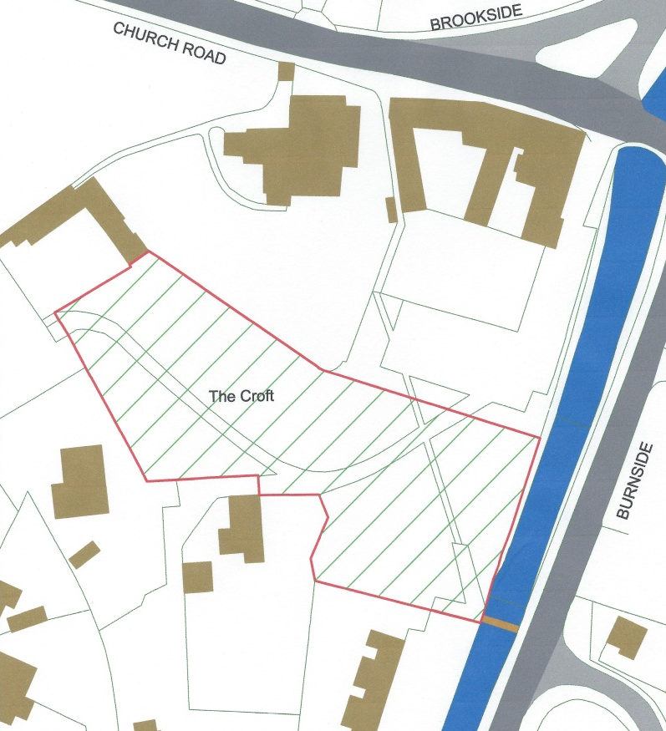

- The Croft is a piece of land acquired by the village that in recent years has been established as the village green. The Alder Brook runs alongside it and it is surrounded by some of Rolleston’s most important buildings including St Mary’s Church and its graveyard, the Old Grammar School, the Almshouses and the Spread Eagle Public House. It faces the Commemoration Club across the Alder Brook. The trees in surrounding properties increase with their distance from the green so that the tallest visible are some distance away. This and five very tall limes beside the brook create the feeling of a clearing within a forest.

Jinny Nature Trail and route of the old railway
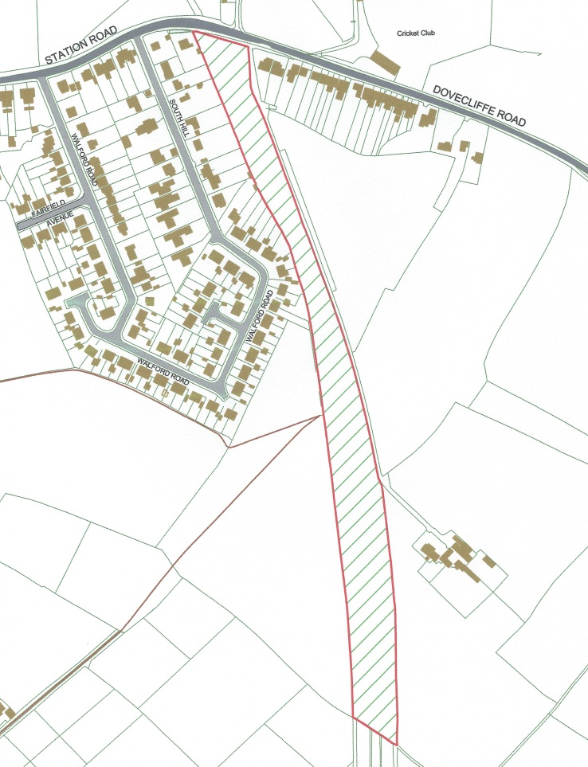

- The trail leads from Station Road along the remaining bed of the railway line to the boundary with Stretton and beyond. It includes the area of the Rolleston on Dove station, some of which is being uncovered and stabilised to create a site of historic interest.

Brook Hollows

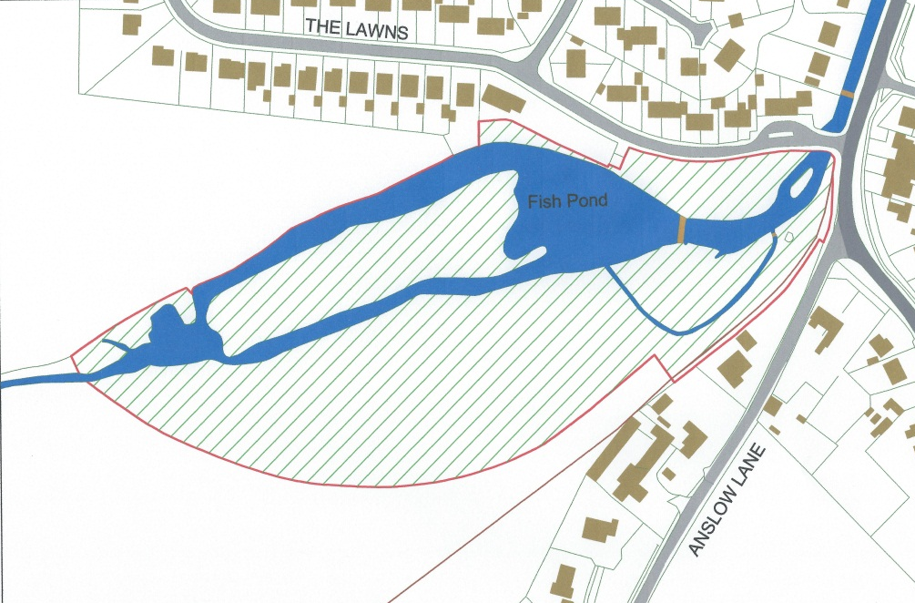

- Brook Hollows, which for a long time was managed by the village is an attractive wood with historic remnants of the fish ponds created on the old Mosley estate. The ‘waterfall’ over the dam is particularly attractive. It is very casual, peaceful woodland enjoyed by residents, particularly the elderly who live within its vicinity.

Section of land on west side of Knowles Hill
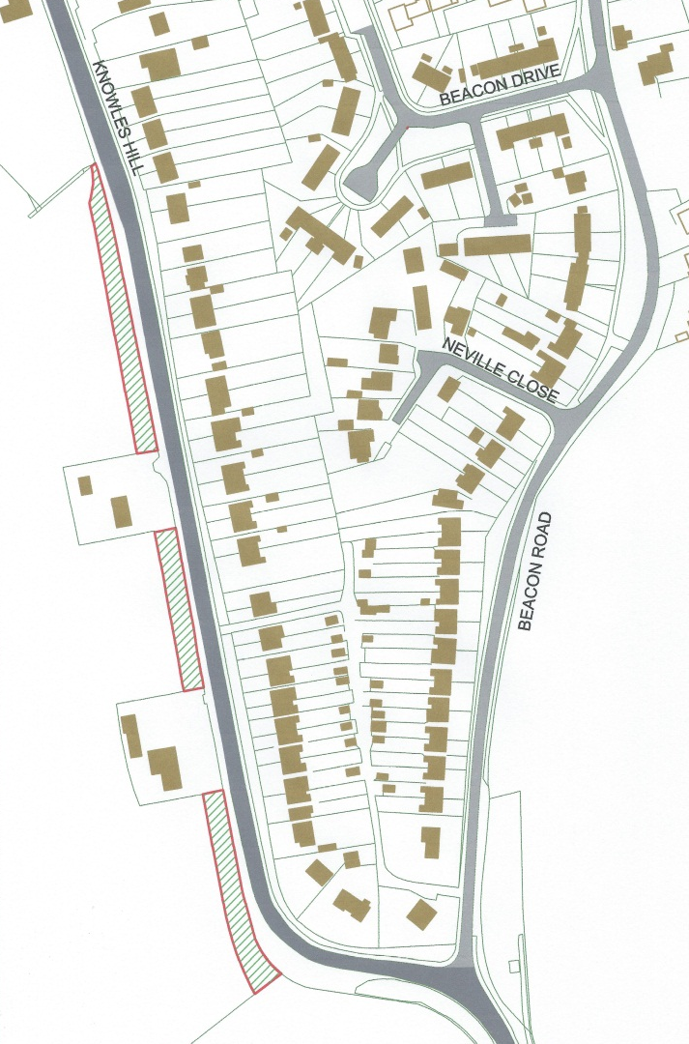

- This strip of land forms the outside, western, edge boundary of the road down Knowles Hill.
- It effectively forms an avenue of tall, well established mature mixed species of trees from the southern entrance to the village to make a scenic link, at the lower end of Knowles Hill, with Brook Hollows. The trees, their natural undergrowth and glimpses through them of live agricultural activity is important in maintaining Rolleston’s rural characteristic.

Plantation by the old swimming pool
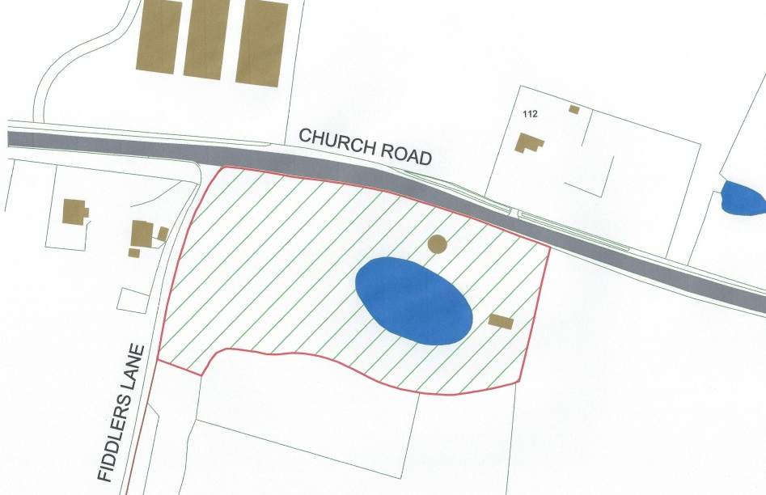

- This area is privately owned and there is an intention to convert the water tower and the old swimming pool and changing rooms, in the water tower, into a dwelling. The trees are fine, tall specimens including redwoods which are very visible from a distance and are a landmark indicating the entrance to the village from the west.

Fiddlers Lane
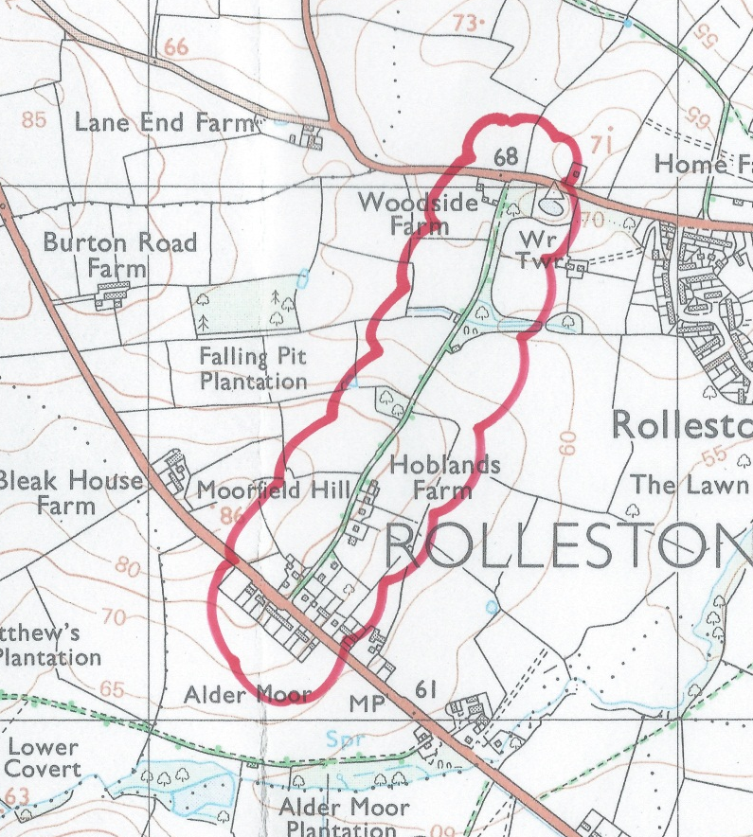

- This is a public, hedged track between Church Road and the A511 and is, apart from its extremities, completely clear of buildings. It passes alongside a small, old established bluebell wood and has views over the old Mosley estate parklands. It is an important link for extended footpath walks around the village.

Brookside
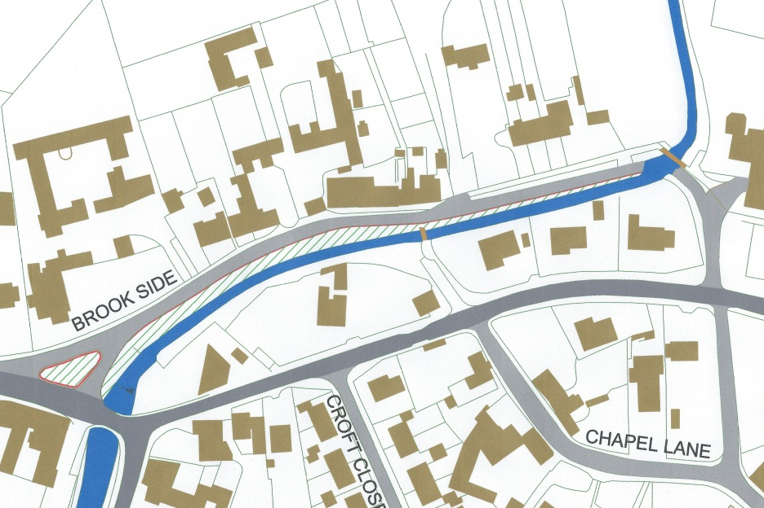

- Other than the fields that surround the village this is the most important and distinctive area in Rolleston, implying its age and its association with agriculture. It creates a rural characteristic at the heart of village. It is a street which feels comfortable, friendly and inviting even if tractor mud occasionally leaves it a bit untidy. It is an important short link between the village centre and the bucolic view from the bridge at the ford and the space between the Brookhouse Hotel and the first cottage on Brookside.

Jitties from Station Road to Meadow View
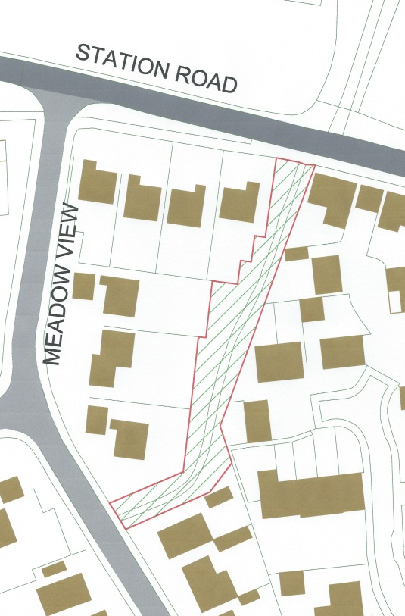 | 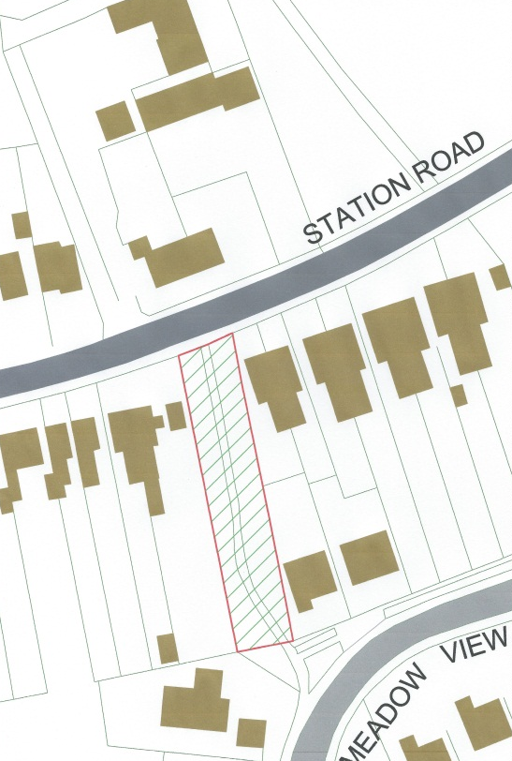

- Both these short metalled pedestrian paths connecting the east and west corner of Meadow View to Station Road and to Forest School Street have wide grass borders and a few substantial trees producing a visual sense of entering a park. As well as providing convenient access to Meadow View and to “Tafflands” they provide a pleasant, peaceful diversion off busy Station Road for people walking the length of the village. This route is particularly enjoyed by school children and their parents as a relaxed and safe part of the journey to and from school.

Twentylands Island/Beacon Drive/Open space on Shotwood Close
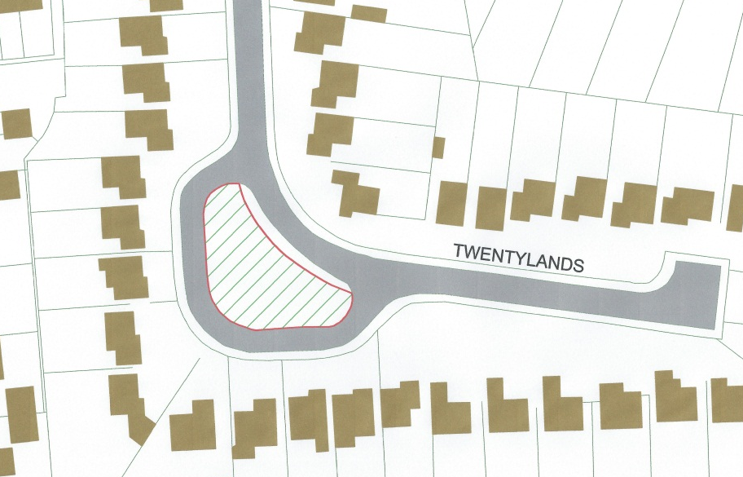
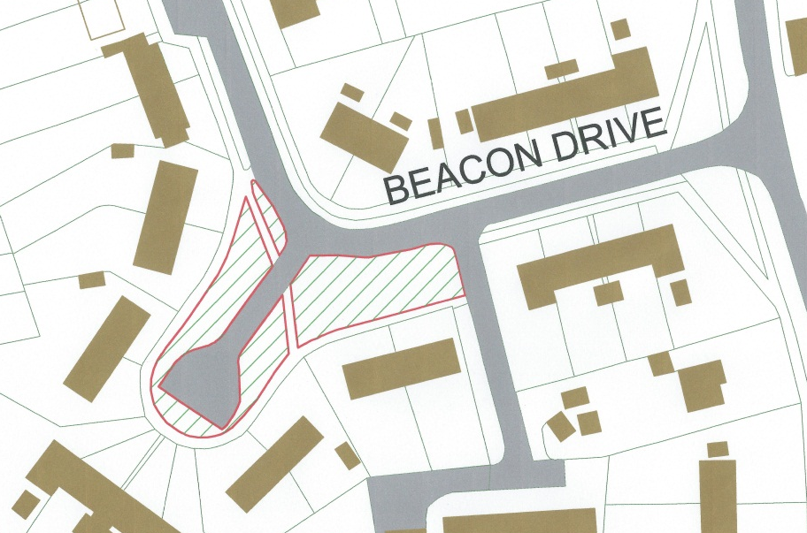
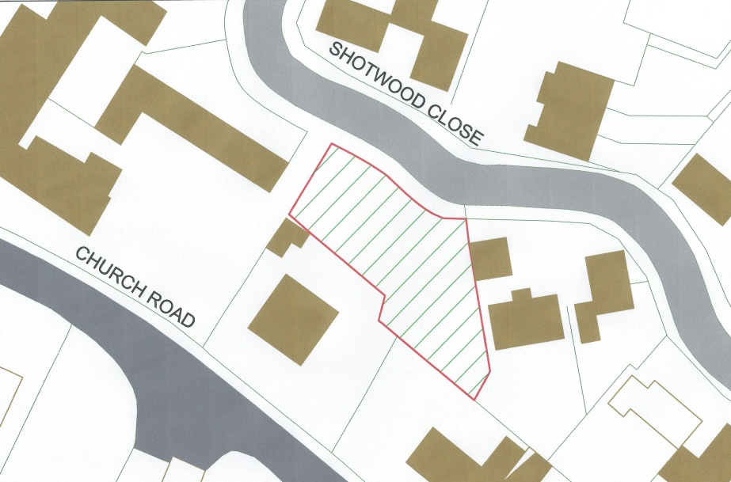

- The traffic island in Twentylands and the green open spaces in Beacon Drive and Shotwood Close are all verdant oases which provide space for trees to develop reasonably and be enjoyed in what would otherwise be fairly enclosed housing areas. They are features which might seem to be unnoticed but actually, though perhaps subliminally, are very much enjoyed by residents and visitors.

Cricket pitches
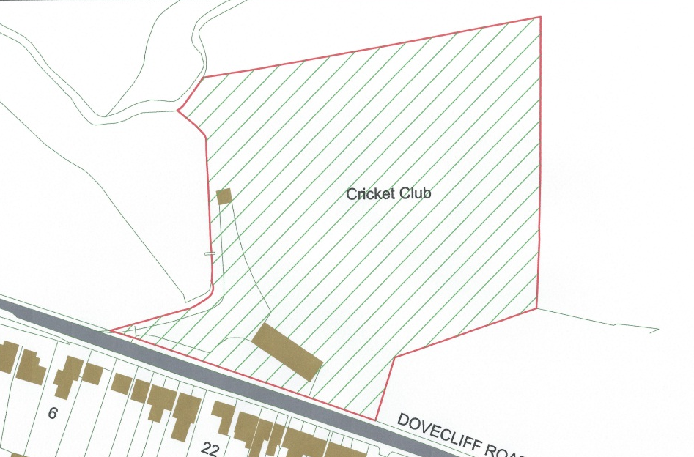

- This very well maintained pitch and pavilion is at the entrance to the village from the east. It is just visible below road level through the roadside hedge. This excites immediate curiosity, a need to explore and a sense of rural style. Looking outwards from the pitch illustrates the attractive aspect of a river plain. The cricket club is significant in promoting the sense of community that the village enjoys.

Orchard adjacent to bottom of South Hill
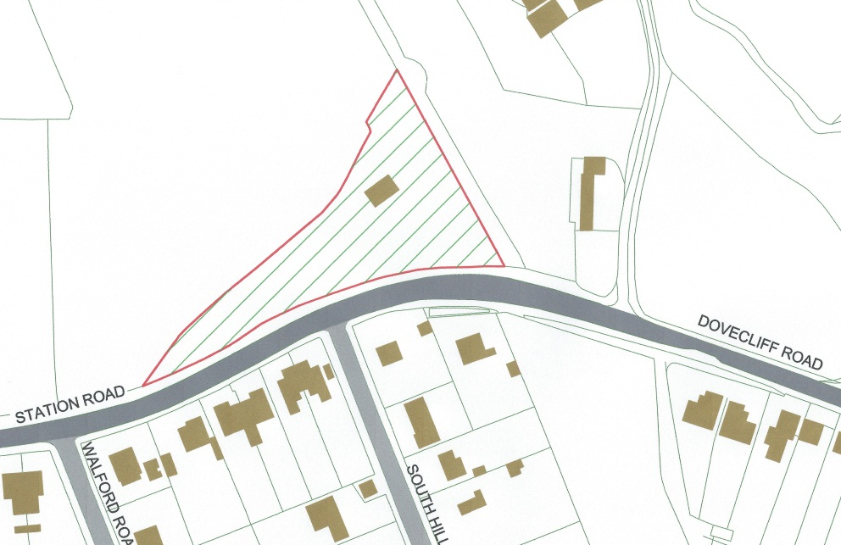

- This small parcel of land on the north side of Station Road, adjacent to the route of the old railway, is an old established orchard with a number of tall fruit trees. It is an attractive and colourful feature at the beginning of Station Road particularly when the trees are in blossom and in autumn when they fruit prolifically.

The Old Dove (SSSI – Site of Special Scientific Interest)
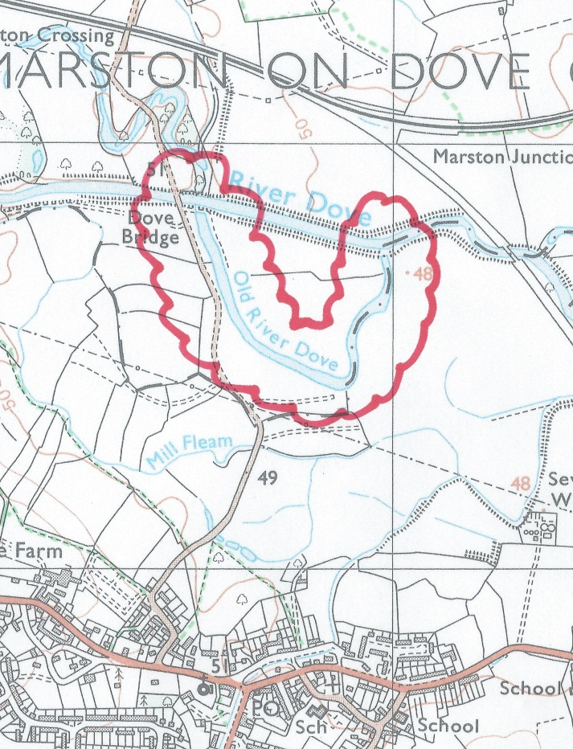

- This oxbow beside Marston Lane has some important plant species and eight species of dragonfly. It is one of the best sites to see dragonflies within adjacent counties. It is an existing Site of Special Scientific Interest so is already afforded a high degree of protection.
The College Playing Fields
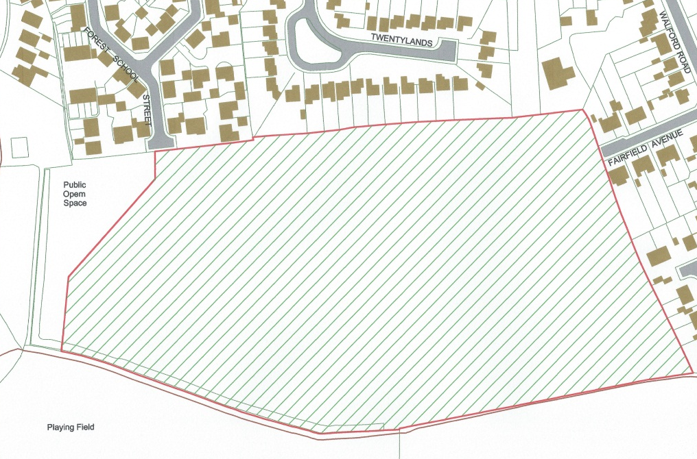

- The College Playing Field is a six-hectare level field that was specifically created for the former Forest of Needwood High School to play a number of sports on. It has a herringbone pattern land drainage system laid all over, making it the best drained sports facility in the area. It is currently used completely free of restrictions by a large numbers of dog walkers, joggers, etc, for recreational purposes. A large section of the community believe that the playing field should be returned to its former use, that of a sports field.

Objectives of the policy
- The intention is to preserve space, both public and private, which is considered important to the residents of Rolleston on Dove. Development on any part of this land should be resisted.

Policy OS2: Protection of open spaces of community value
Development on all or part of the following open spaces of community value will be strongly resisted:
- The Croft (village green)
- Jinny Nature Trail and route of the old railway
- Brook Hollows
- Section of land on west side of Knowles Hill
- Plantation by the old swimming pool
- Fiddlers Lane
- Brookside
- Jitties from Station Road to Meadow View
- Twentylands Island/Beacon Drive/Open space on Shotwood Close
- Cricket pitches
- Orchard adjacent to the bottom of South Hill
- The Old Dove
- The College Playing Fields

Policy OS2
Objective 1: The community accepts some new homes are necessary but these should be built in the most sustainable and least impacting areas of the village, preserving the village atmosphere for future generations. | YES
Objective 2: The prevention of the village of Rolleston on Dove merging into the suburbs of Burton, Stretton and Tutbury, thereby losing its important identity.
Objective 3: The protection of green open space used for sport and recreation. | YES
Objective 4: The scale of development to be in keeping with the village. In particular, large housing developments are not acceptable within the village.
Objective 5: Developments should meet the needs of the local community and be designed to be in keeping with the existing properties in the village.

Protection of views of local importance
- In a rural location such as Rolleston on Dove, it is as important to protect the visual ‘feel’ of being in a village as it is to protect the spaces that are used. It is therefore considered important to protect some of the most important views of the surrounding land from the village.

Justification
- The consultation process has identified a number of different views from the village which members of the community consider make a positive contribution to life in Rolleston on Dove. These are as follows:
View from the bridge at the Brookhouse
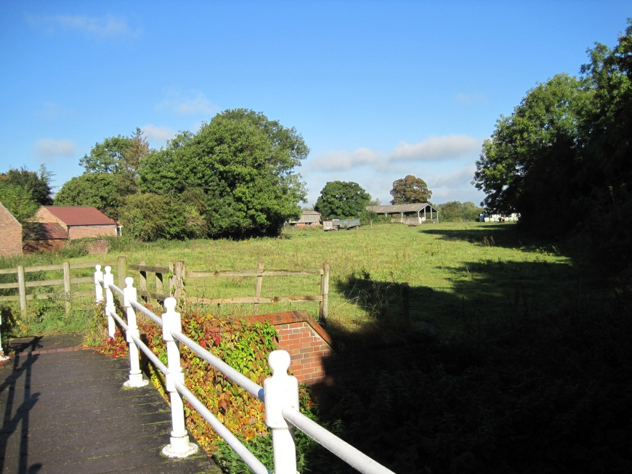

- Other than the fields that surround the village this is the most important and distinctive area in Rolleston on Dove, implying its age and its association with agriculture. It creates a rural characteristic at the heart of village.
- The pastoral view from this bridge is a major contribution to the importance of Brookside’s influence on the character of the village. It is very important then that we endeavour to protect the farmland, immediately visible beyond the bridge, from housing or drastic changes of agriculture.

View of the fields on the north side of Station Road
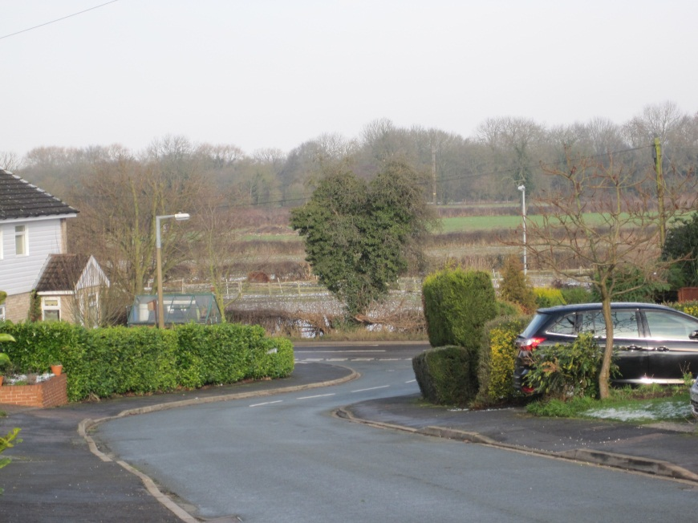

- Much of the agriculture around Rolleston on Dove now uses fairly large fields. There is an area stretching north from Station Road, particularly between The Jinny Inn and the line of the old railway, where fields are relatively small, with well-maintained hedges and are reminiscent of the fields systems of an earlier age. Glimpses of them from Station Road are a pleasant ever present reminder of Rolleston’s history and the origins of the village’s current characteristics. The views when walking down the hills in Walford Road and Twentylands are particularly attractive, as they are from the Station Road houses. The village should endeavour to protect the whole of this area from housing development or significant changes in agriculture destroying the field system.

Objectives of the policy
- The intention is to preserve the views which contribute towards Rolleston on Dove’s role as a rural settlement surrounded by views of a landscape considered by the residents to be of high aesthetic value.

Policy OS3: Protection of views of local importance
Development will be strongly resisted if it impacts in any way on the following views:
- The view from the bridge at the Brookhouse
- The view of the fields on the north side of Station Road

Policy OS3
Objective 1: The community accepts some new homes are necessary but these should be built in the most sustainable and least impacting areas of the village, preserving the village atmosphere for future generations. | YES
Objective 2: The prevention of the village of Rolleston on Dove merging into the suburbs of Burton, Stretton and Tutbury, thereby losing its important identity.
Objective 3: The protection of green open space used for sport and recreation.
Objective 4: The scale of development to be in keeping with the village. In particular, large housing developments are not acceptable within the village.
Objective 5: Developments should meet the needs of the local community and be designed to be in keeping with the existing properties in the village.

infrastructure
- The community was asked to consider what physical and community infrastructure the parish lacked or needed improving. A significant response was that a community centre was required to serve the village. Currently Rolleston on Dove does not have any form of community centre and the Parish Council does not have an office which the general public can visit. The only public facility which people can hire at present is the Scout Hall. However, this is used on most evenings by the Scout Group, so is unable to serve the needs of people when they most need it.
- Other specific facilities were identified. These broadly come under the headings of ‘sports/leisure facilities’ and ‘transport infrastructure’.

Community facilities

Justification
- Consultation with the community identified that a community facility was required to provide a meeting venue for community groups. Ideally, this meeting facility would also have kitchen facilities. Also, the Parish Council currently does not have an office so meetings between members of the public and the parish clerk have to take place at the clerk’s house. Therefore, the facility would need to have an office and small meeting room.
- Such a facility would have to be funded principally from developer contributions and an appropriate site found.
- Contributions from development will be collected either through a Community Infrastructure Levy (CIL) or by Section 106 agreement. Whilst the CIL Regulations will restrict the pooling of Section 106 contributions, this is only where there are five or more contributions. Therefore, the two allocated sites can all contribute towards the new community facility without contravening the Regulations.

Objectives of the policy
- The aim is to deliver the most important piece of community infrastructure which the local community wants. The policy recognises the importance of funding for its delivery being secured through a combination of developer contributions and other funding sources.

Policy IN1: Provision of a community centre
A community facility comprising, as a minimum, a main hall, small meeting room, office for the Parish Council and basic amenities, shall be provided when an appropriate site is identified and is made available. The appropriateness of a community facility on such a site will be subject to the other policies in this plan.
The cost of construction of the new facility and the land for this facility will principally be met through the pooling of developer contributions from new development in Rolleston on Dove parish.
ent w

Policy IN1
Objective 1: The community accepts some new homes are necessary but these should be built in the most sustainable and least impacting areas of the village, preserving the village atmosphere for future generations.
Objective 2: The prevention of the village of Rolleston on Dove merging into the suburbs of Burton, Stretton and Tutbury, thereby losing its important identity.
Objective 3: The protection of green open space used for sport and recreation.
Objective 4: The scale of development to be in keeping with the village. In particular, large housing developments are not acceptable within the village.
Objective 5: Developments should meet the needs of the local community and be designed to be in keeping with the existing properties in the village. | YES

Sports/leisure facilities

Justification
- Consultation with the community identified that there was considerable demand for the following infrastructure to serve the community:
- Changing rooms serving the sports pitches at Craythorne Playing Fields
- New allotment space
- College Field to be returned to an operational sports ground
- The provision of allotment space will need to be accommodated on sites other than those allocated for housing development (Policy H5). These should ideally be easily accessible by the majority of the inhabitants of Rolleston village using non-car modes of transport.
- The changing rooms to serve the sports pitches at Craythorne Playing Fields should ideally be adjacent to the pitches or at least a very short walk away.
- These infrastructure needs will principally be funded through developer contributions. These contributions will be collected either through CIL or by Section 106 agreement. It is important to recognise that the most important item of infrastructure identified is the new community centre, so significant levels of developer contribution must be set aside for this to be delivered later in the plan period.
- Contributions should also be sought from other sources, including grant funding.

Objectives of the policy
- The aim is to deliver community infrastructure which the local community considers is lacking in the parish. It ensures that it is capable of being funded through a combination of developer contributions and other funding sources.

Policy IN2: Provision of sports/leisure facilities
The following sports/leisure facilities shall be provided in Rolleston village:
- Changing rooms serving the sports pitches at Craythorne Playing Fields
- New allotment space
- College Field returned to an operational sports ground

The provision of the new facilities will principally be met through the pooling of developer contributions from new development in Rolleston on Dove parish.
A co

Policy IN2
Objective 1: The community accepts some new homes are necessary but these should be built in the most sustainable and least impacting areas of the village, preserving the village atmosphere for future generations.
Objective 2: The prevention of the village of Rolleston on Dove merging into the suburbs of Burton, Stretton and Tutbury, thereby losing its important identity.
Objective 3: The protection of green open space used for sport and recreation. | YES
Objective 4: The scale of development to be in keeping with the village. In particular, large housing developments are not acceptable within the village.
Objective 5: Developments should meet the needs of the local community and be designed to be in keeping with the existing properties in the village. | YES

Transport facilities

Justification
- The community identified transport improvements as being required, both to address existing problems as well as needs that are expected to arise through new development. These improvements represent a combination of improved public transport, parking and traffic calming measures:
- Replacement of existing bus shelters throughout the parish
- Speed reduction measures on Knowles Hill
- Parking bay outside shops in Rolleston village
- Bus usage in Rolleston village is significant and many people cited the need for new bus shelters. Ideally, these should have real time passenger information (RTPI) to provide information on bus arrival times.
- Knowles Hill has been identified by residents as a road of particular concern regarding highway safety. There is a need to use traffic calming measures at very least to alert drivers to their speed. This could be through the siting of a speed camera or appropriate speed display signage at a point or points along the road.
- The lack of short term parking outside the shops in Rolleston village was cited as an issue and long term solutions need to be investigated. Some solutions were considered but none were considered to be practical.
- These infrastructure needs will principally be funded through developer contributions. These contributions will be collected either through CIL or by Section 106 agreement. However, certain items such as new bus shelters and speed reduction measures should also be considered as part of ongoing local transport planning work by Staffordshire County Council.

Objectives of the policy
- The aim is to deliver transport infrastructure which the local community considers is needed in the parish to address safety concerns and the needs associated with growth.

Policy IN3: Provision of transport infrastructure
The following transport infrastructure shall be provided in Rolleston village:
- Replacement bus shelters throughout the village with real time passenger information (RTPI)
- Appropriate speed reduction measures on Knowles Hill
- Additional parking outside the shopping area
- Changing rooms

Policy IN3
Objective 1: The community accepts some new homes are necessary but these should be built in the most sustainable and least impacting areas of the village, preserving the village atmosphere for future generations.
Objective 2: The prevention of the village of Rolleston on Dove merging into the suburbs of Burton, Stretton and Tutbury, thereby losing its important identity.
Objective 3: The protection of green open space used for sport and recreation.
Objective 4: The scale of development to be in keeping with the village. In particular, large housing developments are not acceptable within the village.
Objective 5: Developments should meet the needs of the local community and be designed to be in keeping with the existing properties in the village. | YES
S

http://www.eaststaffsbc.gov.uk/Services/Statistics%20Documents/Rolleston%20on%20Dove.pdf - p.18-23
http://www.eaststaffsbc.gov.uk/Services/Statistics%20Documents/Rolleston%20on%20Dove.pdf
Source: ESBC, Settlement Hierarchy Topic Paper, July 2012, Table 5
Source: ESBC Local Plan Preferred Option, July 2012, paragraph 5.63
Source: Department for Education
‘Close proximity’ is considered to be within 400m of the property

